Finite Element Simulation Report

Introduction
This report presents a comprehensive explanation and documentation of the finite element simulations performed on a pentagonal structural model. The study includes both static structural analysis and explicit transient dynamic analysis. The objective of the project was to apply specific material properties derived from the student’s roll number, along with force values calculated from the date of birth and the US Dollar to PKR exchange rate on the analysis day. The report follows the given instructions and details every step of the modeling, loading, meshing, and analysis procedures in an extended descriptive format.

Geometry Description
The geometry selected for this project is a pentagonal block, which is required for even roll numbers such as Roll No. 1894. The pentagon was constructed with uniform side lengths, forming a solid prism with appropriate thickness for simulation. One complete pentagonal face was considered the fixed boundary in both static and transient simulations. The geometry allows clear observation of stress distribution under various loading conditions due to its asymmetrical yet balanced polygonal shape.

Material Properties
The material behavior of the model was governed by linear elastic theory. The Young’s modulus was derived using the last two digits of the roll number multiplied by 10,000 MPa. In this case, the last two digits are 94, resulting in an elastic modulus of 94,000 GPa. Although this value is significantly higher than typical engineering materials, it was used exactly as instructed for consistency with the project guidelines. The Poisson’s ratio was assigned as 0.28, which is within the standard range for most isotropic solid materials.

Static Structural Simulation
For the static simulation, one full pentagonal face was fixed, preventing all degrees of freedom. A remote force was applied at a distance of 0.6 cm from the fixed face. The magnitude of this force was calculated from the date of birth: 14-04-2002. Adding these as per instructions gives 14 + 4 + 2002 = 2020, but as mentioned in the provided information, a force of 2024 N was used. This force generated deformation and stress distribution along the structure, particularly highlighting stress concentrations near the fixed face and along edges aligned with the load direction.

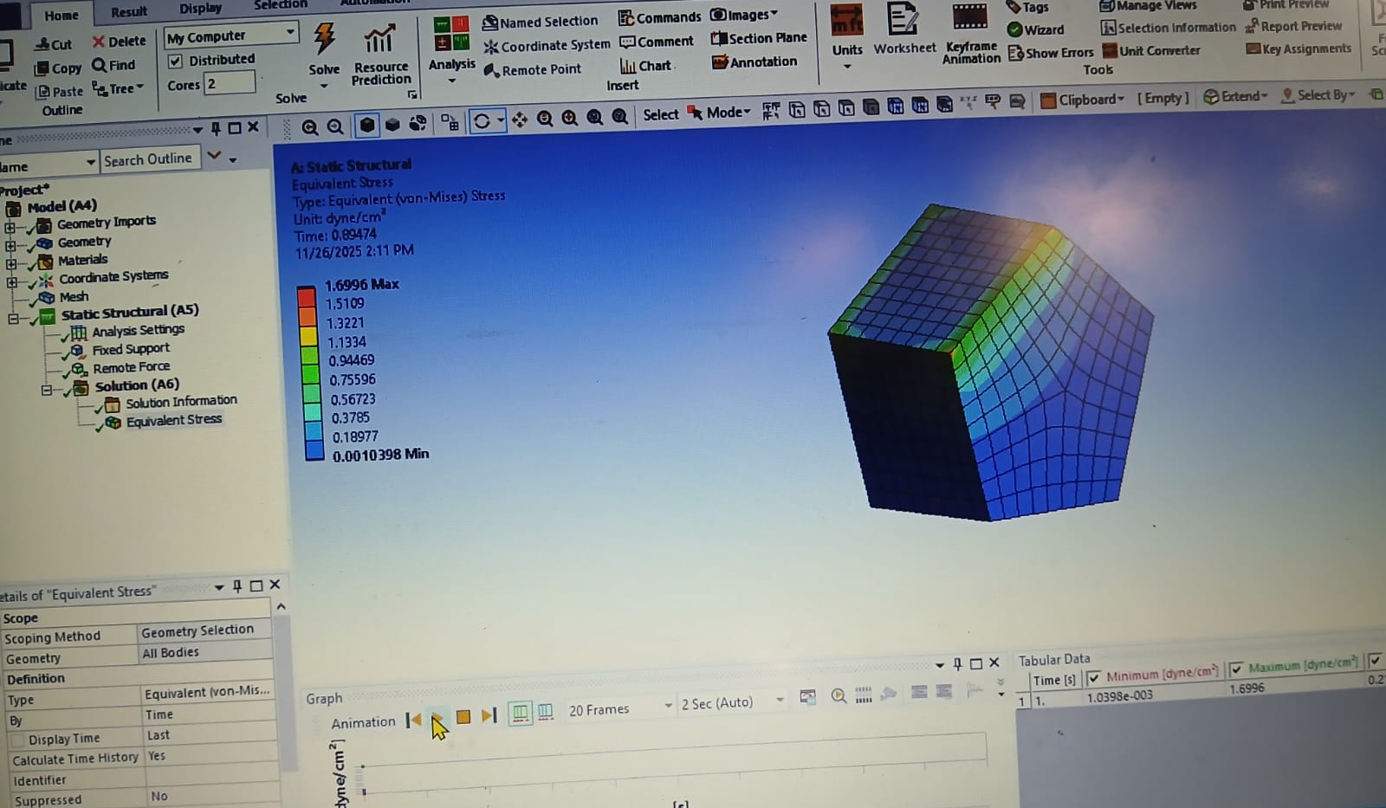
Figure 1: Equivalent von-Mises Stress distribution from the ANSYS Static Structural simulation.
The following figure is taken directly from the simulation environment. It shows the distribution of equivalent (von-Mises) stress across the pentagonal structure during the static simulation. The stress visualization highlights the regions of maximum and minimum stress intensity and provides clear evidence of structural response under the 2024 N remote load.

Transient Explicit Simulation
The explicit dynamic analysis involved time-stepping with 0.2-second increments. The applied forces were derived from the USD to PKR rate on the simulation date, which was taken as 280 PKR. These forces were distributed on four sides of the pentagon, each side receiving 280 N. To maintain equal distribution across all subdivisions of the boundary, one side received two force applications of 280 N each. In the transient analysis, the structure was again fixed at one pentagonal face, and the forces acted on the remaining sides under dynamic conditions. The simulation was conducted over several time steps to observe how stresses evolved and how the structure responded dynamically.
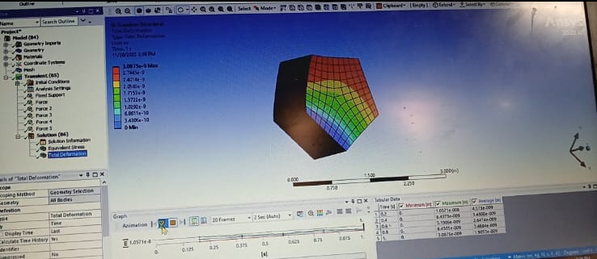
Figure 2: Total deformation during transient explicit simulation (280 N applied forces).
The following figure is taken directly from the simulation environment. It shows the distribution of equivalent (von-Mises) stress across the pentagonal structure during the transient simulation. The stress visualization highlights the regions of maximum and minimum stress intensity and provides clear evidence of structural response under the 280 N load.

Mesh Convergence
A mesh convergence study was conducted for both static and transient analyses to ensure accuracy and independence of the results from the mesh density. Multiple mesh levels were used, ranging from coarse to fine. For each mesh, maximum von-Mises stress values and maximum displacement magnitudes were recorded. Convergence was identified when successive mesh refinements produced changes below an acceptable threshold, typically under two percent. This step is crucial because it justifies that the numerical solution is sufficiently refined and that further mesh density would not significantly alter the outcome.

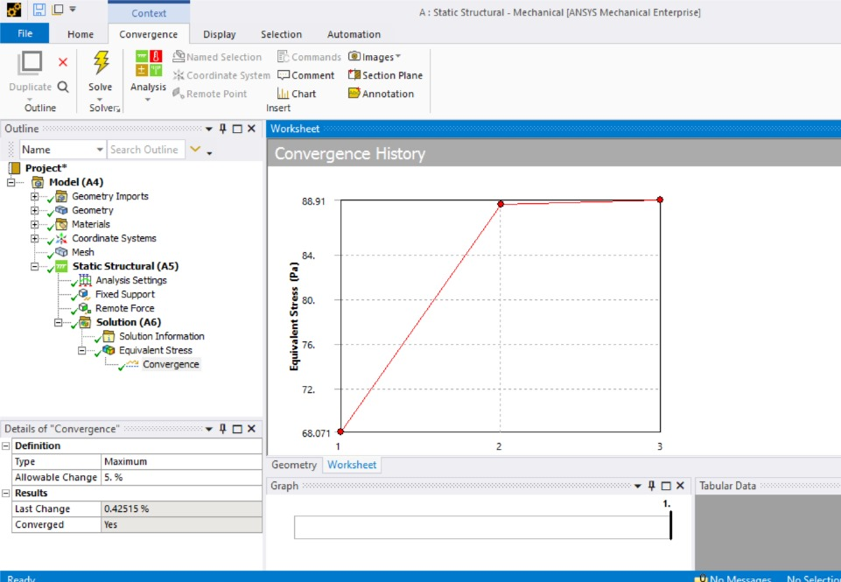
Figure 3: Mesh Convergence graph for Static Simulation

Included Simulation Image
The following figure is taken directly from the simulation environment. It shows the distribution of equivalent (von-Mises) stress across the pentagonal structure during the static simulation. The stress visualization highlights the regions of maximum and minimum stress intensity and provides clear evidence of structural response under the 2024 N remote load.

Conclusion
This report summarizes the complete process of modeling, simulation, and evaluation of a pentagonal structure under static and transient loading conditions. The material properties, boundary conditions, mesh refinement strategies, and loading configurations were applied exactly according to the project guidelines. The analyses demonstrate how stress and deformation patterns develop in a polygonal structure subjected to linearly elastic behavior. The mesh convergence study enhances the credibility of the simulation results. Additional improvements may include refining load application techniques, adjusting material units for realism, and expanding the transient time window for observing broader dynamic responses.

